1. Black-Scholes option pricing

Suppose the stock price is 40 and we need to price a call option with a strike of 45 maturing in 4 months. The stock is not expected to pay dividends. The continuously-compounded riskfree rate is 3%/year, the mean return on the stock is 7%/year, and the standard deviation of the stock return is 40%/year.

*S* = 40 (the current stock price as given), and *B* = 45exp(−*.*03(1*/*3)) ≈ 44*.*55224. Note that 1*/*3 is the time to maturity 4*/*12 months.

1. What are *x*1 and *x*2?

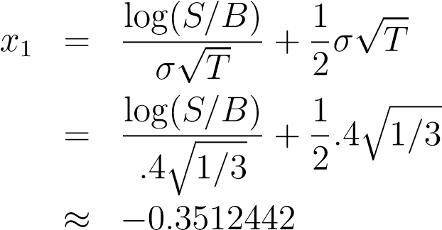

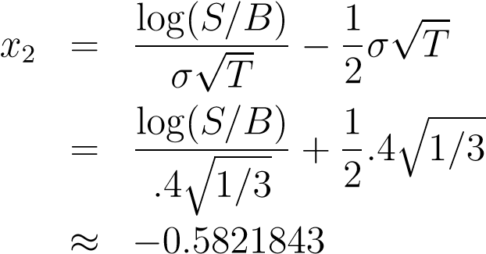

1. *N*(*x*1) = 0*.*3627026 and *N*(*x*2) = 0*.*2802213 (confirm for yourself if you like). What is the Black-Scholes call price?

*C* = *SN*(*x*1) − *BN*(*x*2)

≈ 40 × 0*.*3627026 − 44*.*55224 × 0*.*2802213

≈ 2*.*023617

1. What is the Black-Scholes price for the Yara Inc put with the same strike and maturity?

By put-call parity, *S* + *P* = *B* + *C*, and therefore the price is

*P* = *B* + *C* − *S*

≈ 44*.*55224 + 2*.*023617 − 40

≈ 6*.*57586

1. Conceptual question: Since the put option is worth more alive than if exercised now (45 −is worth40 = 5the*<* 6same*.*57586)Yara Inc we conclude put? that an American version of the put

No. The value today is enhanced by our option to exercise an American option between now and maturity.

2. Approximation

As noted in class, for near-the-money call options, a good approximation to the option price is

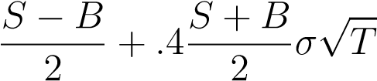

where *S* is the stock price, *B* the present value of receiving the strike at maturity, *σ* is the local standard deviation, and *T* is the time to maturity.

Consider an at-the-money call option that is one week to maturity on a stock with a local standard deviation of 35%/year. If the stock is selling for $50 and the continuously-compounded riskfree rate is 1%/year, then the BlackScholes call option price is $0.9727852.

a. What is the call price from the approximate formula?

*T* = 1*/*52, *S* = 50, *B* = 50exp(−*.*01 × 1*/*52) ≈ 49*.*9903855, *σ* = *.*35

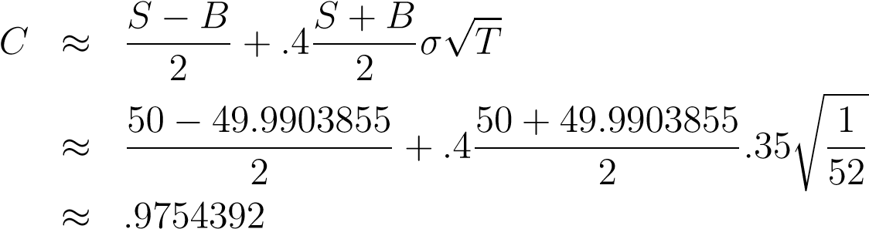

1. What is the error from using the approximate price?

*.*9754392 − *.*9727852 ≈ $0*.*00265

(about a quarter of a cent)

1. What is the corresponding European put price using the approximation? (Use put-call parity. The Black-Scholes put price is $0.963.)

By put-call parity, *P* = *B*+*C*−*S*, so the put price is 49*.*9903855+0*.*9754392− 50 ≈ $0*.*9658247

**Useful Formula**

The Black-Scholes call price is

*C*(*S,T*) = *SN*(*x*1) − *BN*(*x*2)*,*

where *S* is the stock price, *N*(·) is the cumulative normal distribution function, *T* is time-to-maturity, *B* is the bond price *Xe*−*rfT*, *rf* is the continuously compounded riskfree rate, *σ* is the standard deviation of stock returns,

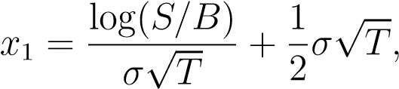

and

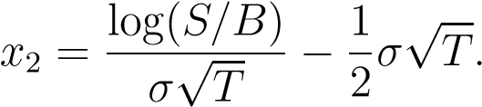

Note that log(·) is the natural logorithm.

Bitcoin (BTC) Stock-to-Flow (S2F) model was [published in March 2019](https://medium.com/@100trillionUSD/modeling-bitcoins-value-with-scarcity-91fa0fc03e25). The original BTC S2F model is a formula based on monthly S2F and price data. Since the data points are indexed in time order, it is a time series model. This model has activated quantitative analysts around the world. Many have verified the non-spurious relationship between S2F and BTC price

**Phase Transitions**

Phase transitions are an important perspective in understanding S2FX model. During phase transitions, things get totally different properties. Transitions are often discontinuous. Three examples of phase transitions are:

1. Water
2. US Dollar
3. BTC

**Water**The classic example of phase transitions is water. Water exists in four different phases (states): solid, liquid, gas, ionized. It is all water, but water has totally different properties in each phase.

**BTC**  
Same is true for BTC. Nic Carter and Hasu show in their 2018 study how BTC narratives changed over time

These BTC narratives seem very continuous in the chart. However, if we combine the narratives with financial milestones (and later S2F and price data), they look very much like phases with more abrupt transitions:

1. “Proof of concept” -> after Bitcoin white paper [5]
2. “Payments” -> after USD parity (1BTC = $1)
3. “E-Gold” -> after 1st halving, almost gold parity (1BTC = 1 ounce of gold)
4. “Financial asset” -> after 2nd halving ($1B transactions per day milestone, legal clarity in Japan and Australia, futures markets at CME and Bakkt)

These three examples of phase transitions in water, US Dollar and BTC offer a new perspective on BTC and S2F. It is important to not only think in term of continuous time series but also in phases with abrupt transitions. In developing S2FX model, I see BTC in each phase as a new asset, with totally different properties. A logical next step is identifying and quantifying BTC phase transitions.

**BTC S2F Cross Asset (S2FX) Model**

The chart below shows the monthly BTC S2F and price data points used in the original S2F model. One can visually identify four clusters.

**WHY IT IS A BAD MODEL**

PlanB’s paper “[Modeling Bitcoin Value with Scarcity](https://medium.com/@100trillionUSD/modeling-bitcoins-value-with-scarcity-91fa0fc03e25)” states that certain precious metals have maintained a monetary role throughout history because of their unforgeable costliness and low rate of supply. For example, gold is valuable both because new supply (mined gold) is insignificant to the current supply and because it is impossible to replicate the vast stores of gold around the globe. PlanB then argues this same logic applies to bitcoin, which becomes more valuable as new supply is reduced every four years, ultimately culminating in a supply of 21 million bitcoin.

Low rate of supply, which PlanB defines as “scarcity,” can be quantified using a metric called Stock-to-Flow (SF), which is the ratio between current supply and new supply.

This premise is then translated into the hypothesis, “…that scarcity, as measured by SF, directly drives value.” PlanB then plots bitcoin’s SF against USD market capitalization as well as two arbitrarily chosen SF data points for gold and silver. PlanB then runs a linear regression using the natural logarithm of bitcoin’s SF metric as the independent variable and the USD market capitalization as the dependent variable. The paper ends with the conclusion that there is a statistically significant relationship between USD market capitalization and SF values, as evidenced by the linear regression resulting in an R2 (a statistical measure of how close the data fits to a regression line) of ~0.95. The two randomly chosen data points for gold and silver are in line with bitcoin’s trajectory and presented as further evidence of the hypothesis.

PlanB suggests that investors can forecast the future USD market capitalization of bitcoin using the above formula. This has helped give credence to those $100,000 bitcoin projections.

**Problems abound**

There are several deficiencies within the paper, both in its theoretical proposition and its empirical foundation.

From a theoretical point of view, the model is based on the rather strong assertion that the USD market capitalization of a monetary good (e.g. gold and silver) is derived directly from their rate of new supply. No evidence or research is provided to support this idea, other than the singular data points selected to chart gold and silver’s market capitalization against bitcoin’s trajectory.

THIS BECOMES QUITE OBVIOUS WHEN ONE EXTENDS THE MODEL INTO THE NEAR FUTURE. BY 2045, THE MODEL ESTIMATES EACH BITCOIN WILL BE WORTH $235,000,000,000.

The second is the naïve application of a linear regression that results in a high probability of a researcher finding spurious results. “Good” statistical results, such as a high R-square, do not constitute a meaningful finding. It is common for researchers to underestimate how often such techniques lead to false results. And particularly in this situation, where there is a large degree of freedom for random data to fit a specific outcome.

**Gold and the dollar**

From a theoretical perspective, what PlanB defines as “scarcity” is not scarcity by definition. PlanB uses “scarcity” to describe an asset’s supply growth rate or new production as measured by the SF metric. This assumes that increasing new supply depresses price through increased selling pressure from producers and vice versa.

This seems reasonable at first glance until one considers that a high SF represents a dynamic where new supply is insignificant to the current supply. PlanB quotes [“Bitcoin Standard”](https://www.amazon.com/Bitcoin-Standard-Decentralized-Alternative-Central/dp/1119473861) author Saifedean Ammous saying as much: *“For gold, a price spike that causes a doubling of annual production will be insignificant, increasing stockpiles by 3% rather than 1.5%.”*

## Perhaps unsurprisingly then, SF has no direct relationship with gold’s value over the last 115 years, as can be seen in the scatter plot below. Gold’s market capitalization held valuations between ~$60 billion to ~$9 trillion, all at the same SF value of 60. A range of $8 trillion is not very indicative of explanatory power and lends itself to the obvious conclusion that other factors drive gold’s USD valuation. **$235 billion bitcoin to infinity**

An entire overview of linear regression and its mathematical basis is beyond the scope of this analysis. However, there are several implementation errors well-established in the [research community](https://www.hindawi.com/journals/jps/2009/802975/) that demonstrate why the SF model is likely to be spurious. Obscure math has allowed SF proponents to dismiss all criticism so it may be more intuitive to understand conceptually why the SF model is irrelevant for future price predictions.

The model supplied in the SF paper is the same slope-intercept equation everyone learns in 7thgrade: *y = mx + b*. An ordinary-least-squares (OLS) regression is not a predictive model but rather an estimation of the *m* and *b* values that minimize the difference between the actual *y* values and the estimated *y* values given by the equation *mx+b*. In other words, every change in *x* equates to a corresponding change in *y*.

**Marketing piece**

Darrell Huff wrote in “[How to Lie with Statistics](http://faculty.neu.edu.cn/cc/zhangyf/papers/How-to-Lie-with-Statistics.pdf)“: “Many a statistic is false on its face. It gets by only because the magic of numbers brings about a suspension of common sense.” Upon reflection, few would take seriously the idea that gold’s USD price is a function of its own supply rate and therefore so is bitcoin’s. Yet, the supposed mathematical precision presented in the paper has resulted in the SF model continuing to be heavily promoted in both retail and professional investment channels.

Investors should be highly skeptical of this model even if they believe bitcoin is digital gold. The SF paper is not proper empirical analysis, but more akin to a marketing piece in which the author is trying to convince readers that bitcoin is going to be worth a lot more tomorrow. This may or may not turn out true, but it has little to do with bitcoin’s supply schedule.